|  |  |  |  |  |
| --- | --- | --- | --- | --- |
| Student Name: | Hanlin Cai |  | Student Name: | 蔡汉霖 |
| Maynooth ID: | 20122161 |  | Fuzhou University ID: | 832002117 |

## EE211 MATLAB Assignment 3:

Personal Statement

Alternatives：**A MATLAB/Simulink environment**

The data set given to me by the TA is shown below:

A = 4; $B_{1}$ = 10; $B_{2}$ =25

All the Code & Picture were designed and created by myself,

and I never share with others.

Procedure 1

The figure of the dynamical system in this assign3 is shown below:

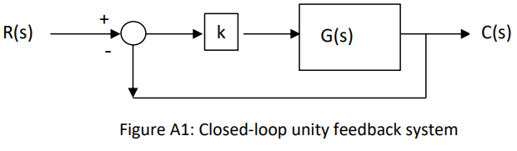

Fig-1

And its transfer function G(s) is given:

$$G\left(s\right)=A\frac{s-1}{s^{2}+B_{1}*s+B_{2}}$$

Where A = 4; $B_{1}$ = 10; $B_{2}$ =25

So, the transfer function is:

$$G\left(s\right)=\frac{4s-4}{s^{2}+10s+25}$$

Firstly, we split the transfer function into 2 parts by defining an intermediate variable Z(s) as follows:

$$\frac{Z\left(s\right)}{U(s)}=\frac{1}{s^{2}+10s+25}$$

$$\frac{Y\left(s\right)}{Z(s)}=4s-4$$

Then, converting to the time domain gives:

$$\ddot{z}+10\dot{z}+25z=u$$

$$4\dot{z}-4z =y$$

Setting the states as

$$x_{1}=z$$

$$x_{2}=\dot{z}$$

Then we get the state equation as follows:

$${\dot{x}}_{1}=x_{2}$$

$${\dot{x}}_{2}=-25x_{1}-10x_{2}+u$$

Giving:

$$\left[\begin{matrix}{\dot{x}}_{1} \\ {\dot{x}}_{2}\end{matrix}\right]=\left[\begin{aligned}0 1 \\ -25 -10 \end{aligned}\right]\left[\begin{matrix}x_{1} \\ x_{2}\end{matrix}\right]+\left[\begin{matrix}0 \\ 1\end{matrix}\right][u]$$

$$\left[y\right]=\left[-4 4\right]\left[\begin{matrix}x_{1} \\ x_{2}\end{matrix}\right]+0$$

So, we know that:

$$A=\left[\begin{aligned}0 1 \\ -25 -10 \end{aligned}\right]$$

$$B=\left[\begin{matrix}0 \\ 1\end{matrix}\right]$$

$$C=\left[-4 4\right]$$

$$D=0$$

Procedure 2

Through Producer1, we have obtained that:

$$\left[\begin{matrix}{\dot{x}}_{1} \\ {\dot{x}}_{2}\end{matrix}\right]=\left[\begin{aligned}0 1 \\ -25 -10 \end{aligned}\right]\left[\begin{matrix}x_{1} \\ x_{2}\end{matrix}\right]+\left[\begin{matrix}0 \\ 1\end{matrix}\right][u]$$

$$\left[y\right]=\left[-4 4\right]\left[\begin{matrix}x_{1} \\ x_{2}\end{matrix}\right]+0$$

So, we can calculate the eigenvalues of the state space system:

$$\left|\begin{aligned}λ -1 \\ 25 λ+10\end{aligned}\right|=0$$

That is：

$$λ^{2}+10λ+25=0$$

So, the eigenvalues are:

$$λ_{1}=λ_{2}=-5$$

Procedure 3

Through the producer1, we have got the transfer function:

$$G\left(s\right)=\frac{4s-4}{s^{2}+10s+25}$$

Then, we can calculate the poles of the transfer function:

$$s^{2}+10s+25=0$$

So, we can easily get the poles:

$$s_{1}=s_{2}=-5$$

Just the same as the eigenvalues calculated in Procedure 2:

$$s_{1}=s_{2}=-5=λ_{1}=λ_{2}$$

Procedure 4

Due to the fact that all the eigenvalues are:

$$Re\left(λ\right)<0$$

And the poles of the dynamical system are:

$$s_{1}=s_{2}=-5<0$$

**Hence, the dynamical system is asymptotically stable and critically damped.**

Procedure 5

Through Procedure1, we have obtained that:

$$A=\left[\begin{aligned}0 1 \\ -25 -10 \end{aligned}\right] B=\left[\begin{matrix}0 \\ 1\end{matrix}\right]$$

$C=\left[-4 4\right]$ $D=0$

So, we use the SIMULINK for simulation:

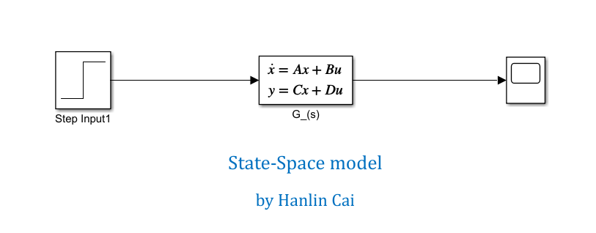

Fig-2

Then we can get the Scope of the transfer function:

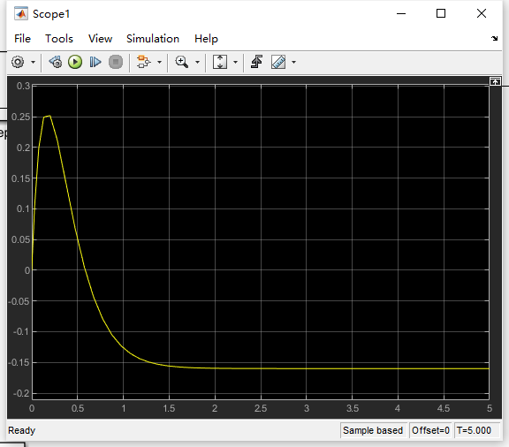

Fig-3

When we change the system input:



$$when system input=0$$

Fig-4



$$when system input=-2$$

Fig-5



$$when system input=+100$$

Fig-6

**So, we can conclude that stability is independent of the system input.**

Procedure 6

We have known that the figure of the dynamical system:

Fig-7

Then, we can use SIMULINK for system simulation:

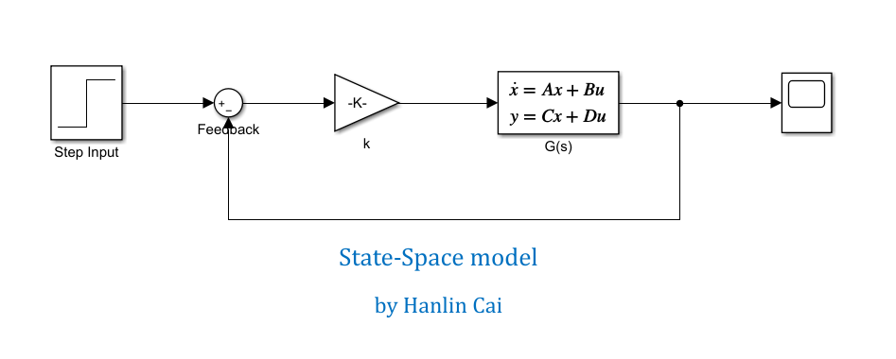

Fig-8

When the $k=2:$

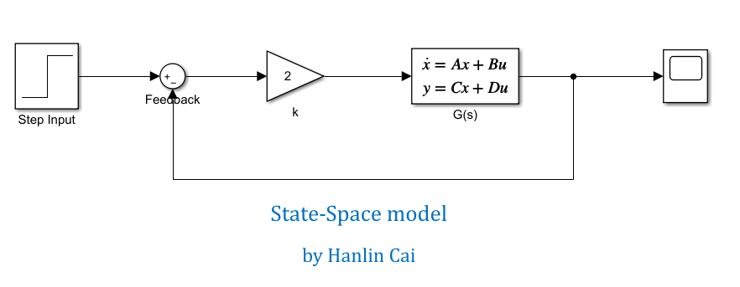

Fig-9

We can get the Scope of the system, as Fig-10 shown, the system is asymptotically stable:

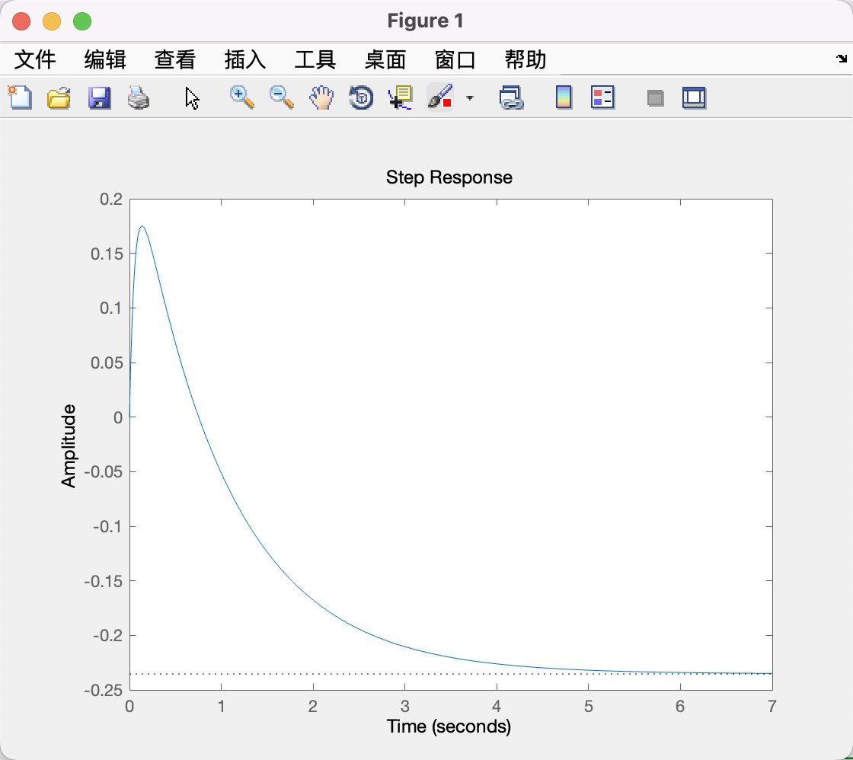

Fig-10

**As Fig-10 shown, the dynamical system is asymptotically stable.**

Procedure 7

We have obtained the SIMULINK simulation for the system:

Fig-11

When we change the value of k, we can get different Scope:

$$when k=+25/4$$

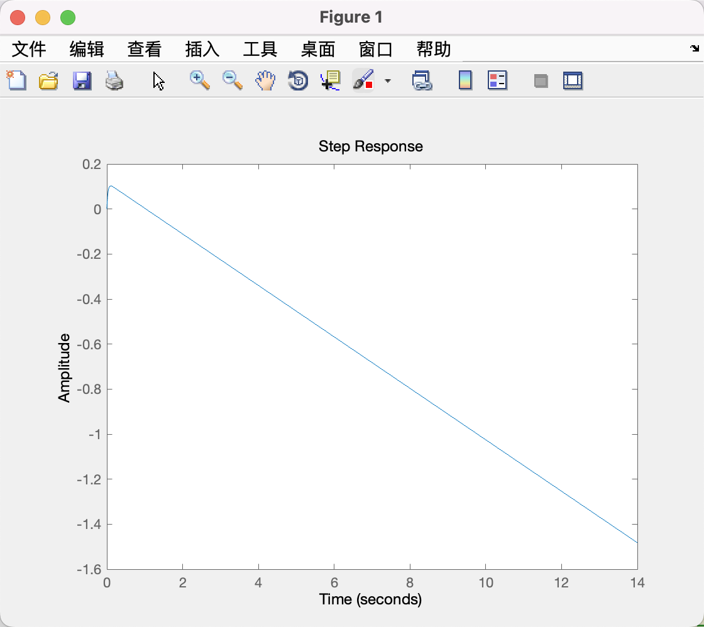

Fig-12 Already Overdamped

$$when k=-5$$

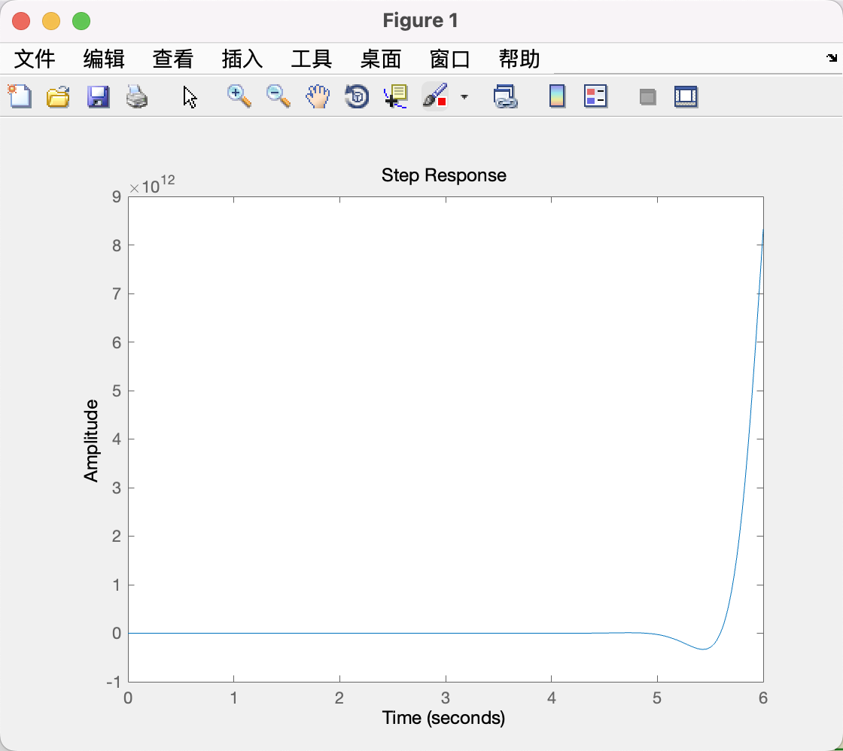

Fig-13 Overdamped

Fig-14 Marginally Stable

$$when k=+10$$

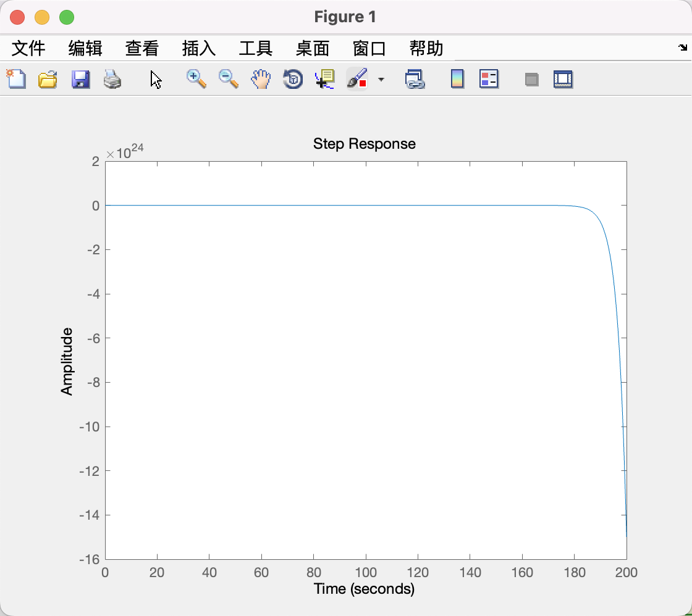

Fig-15 Overdamped

**Comment:**

**As the Fig10-15 shown, when we change different value of k, the transient response will change. When $k is in the scope (-\frac{5}{2} ,+\frac{25}{4})$, the system is asymptotically stable.**

**In this scope, when k become larger, the transient response will become weaker, and the system tends to be overdamped. (When $k=\frac{25}{4}$, the system will already become overdamped.)**

**Meanwhile, when k become smaller, the transient response will become stronger, and the system tends to be overdamped, too. (When $k=-\frac{5}{2}$, the system is marginally stable.)**

**Overall, when $k is in (-\frac{5}{2} ,+\frac{25}{4})$, the system is asymptotically stable. And when $k is out of (-\frac{5}{2} ,+\frac{25}{4})$, the system is unstable.**

Procedure 8 & Procedure 9

We have let $k=2$, and the figure of the closed-loop transfer function (CLTF) for the system is given as Fig-16. So, we can calculate the poles of the system by MATLAB.

手机屏幕截图

Fig-16

Through MATLAB Code shown below, through ‘root’ function, we can get the poles:

$${pole}_{1}= -5$$

$${pole}_{2}= -5$$

Because $poles<0$, so the system is asymptotically stable.

And through the ‘feedback’ function, we can get the state-space representation for the CLTF for the system, as Fig-17 shown.

表格

Fig-17

So, the state-space representation for the CLTF for the system is:

$$\left[\begin{matrix}{\dot{x}}_{1} \\ {\dot{x}}_{2}\end{matrix}\right]=\left[\begin{aligned}0 1 \\ -17 -18 \end{aligned}\right]\left[\begin{matrix}x_{1} \\ x_{2}\end{matrix}\right]+\left[\begin{matrix}0 \\ 1\end{matrix}\right][u]$$

$$\left[y\right]=\left[-4 4\right]\left[\begin{matrix}x_{1} \\ x_{2}\end{matrix}\right]+0$$

And through the ‘eig’ function, we can get the eigenvalues of this system:

$${eigvalue}_{1}= -1$$

$${eigvalue}_{2}= -17$$

Due to the fact that:

$$All Re\left(λ\right)<0$$

So, we can draw the conclusion that:

**The dynamical system is asymptotically stable.**

**MATLAB Code:**

%% Assign3 Hanlin Cai 832002117

% The dataset given to me by the TA is: A = 4; B1 = 10; B2 =25

% Statement: All the Code and Pic were created by myself, and I never share with others.

%% Q4-Q5

% 建立系统状态空间表达式模型 State-Space Modelling

A = [0 1 ; -25 -10];

B = [0;1];

C = [-4 4];

D = 0;

G = ss(A,B,C,D); % Continuous-time state-space model.

% step(G,5) % using a unit step input

% 系统多项式形式的传递函数模型 sys1

sys1 = tf(G); % Continuous-time transfer function.

% 系统零-极点形式的传递函数模型 sys2

sys2 = zpk(sys1); % Continuous-time zero/pole/gain model.

% 系统传递函数多项式形式的分子、分母多项式系数

[num ,den] = ss2tf(A,B,C,D); % Numerator and denominator polynomial coefficients

% 系统零-极点: z为零点，p为极点

[z,p] = ss2zp(A,B,C,D); % z is the zero point, and p is the pole.

%% Q8

% calculate the poles of the closed loop system.

syms s;

sys11 = s^2 + 10*s + 25;

% root(sys11,s);

poles = solve(sys11,s); % poles = -5 & -5

%% Q9

% determine a state-space representation for the closed-loop transfer function (CLTF) for the system in Fig.A1 \

% and calculate the eigenvalues of this system.

k = 2; % when k = 2, the system is asymptotically stable

sign = -1;

SYS = feedback(G,k,sign);

SYS1 = tf(SYS); % Continuous-time transfer function.

eigvalues = eig(SYS); % when k = 2, eigvalues = -1 & -17

%% EE211 Assignment3 MATLAB code by Hanlin Cai

A summary of what I gained in this Assignment3

Through this assignment, I get familiar with how to simulate a complex model by **MATLAB/Simulink**. Although this assignment was very difficult for me at the beginning, I finally finished it well through independent study and continuous trying.

Acknowledgement

I would like to thank my professor, **Zhicong Chen**, and my TA, **Honghui Chen.** I’m really appreciate for your grateful patience, hard-work, and wisdom! Without your help, I could not finish this difficult assignment3 well. Thank you so much!